Show Setup/Take Down

- Where: Save A Lot Complex
722 Highland Road
Highland, MI 48357
- Vendor setup time: 2 PM-4PM
- Enter the Save A Lot complex off of M59 on Enterprise Drive. Turn in at the last drive of the Save A Lot Complex. The curb on the bounce house side of the site is gentle. You can enter there and drive to your site and unpack/setup. After you unload you may circle around and exit where you came in. See below.
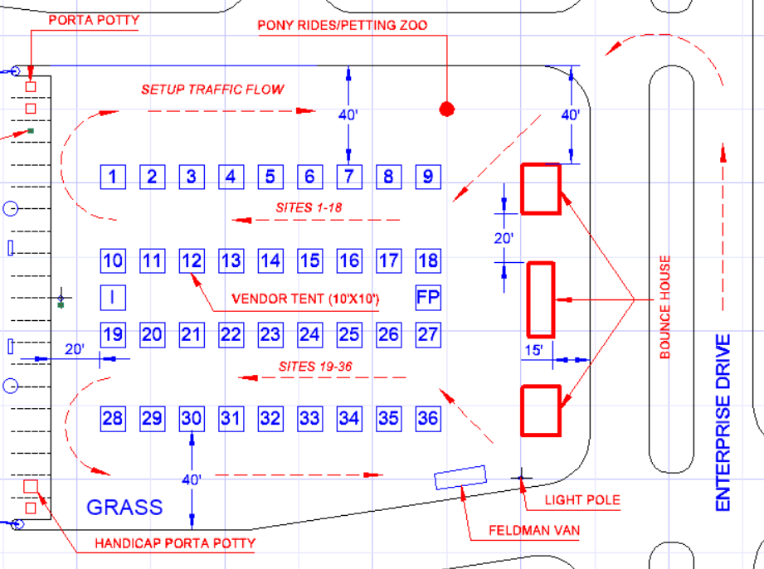

- Look for this sign:

- Drive to your assigned spot. (you should have received an email from us with your site assignment…contact us right away if you did not receive it!). Your site number will be written on a yellow flag. See photos below:

- Center the front side of your tent on the flag. There will be 2 paint lines there. Your 10 ft wide tent should line up with them. If you have a 12 ft tent, you will be past the line by a foot on each side.
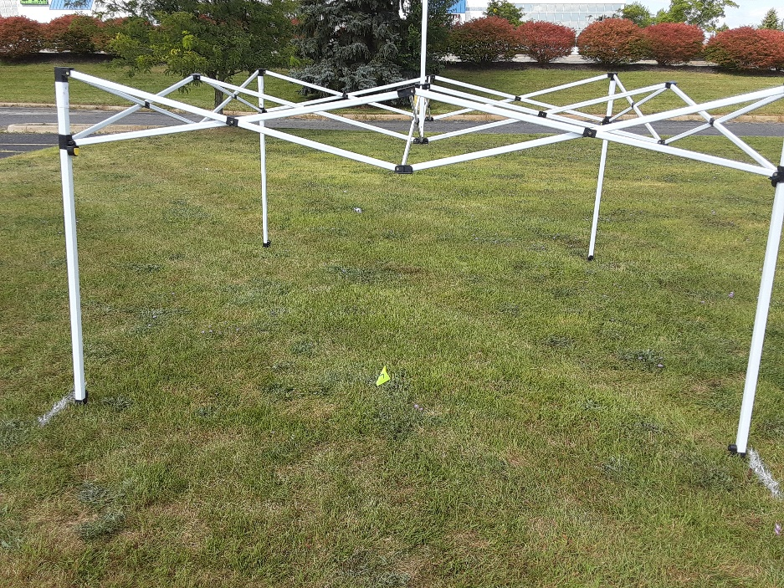

- Unload and set up your site.

- On the plot plan you will see a vendor parking spot location near the massage parlor. You may park there if you wish.

- Come to the Information tent and check in. See the PDF for our site location (Site I). We will check you in and give you your gift bag.

- Departure. We are not enforcing any minimum stay to time. We are not really sure how this will go. We understand there will be a lot of folks at this site to see the fireworks. Apparently, the best place in town to see them…. If you do want to leave and there are a lot of people you may not be able to drive to your site.

